Machine Learning

CSE 8673

Programming Assignment 2

**Student**: Anh Do

**NetID**: aqd14

# Part A: Deliverables

|  |  |  |
| --- | --- | --- |
| **Training set** | **Number of misclassification** | **Fraction of misclassification** |
| 960 documents | 5 | 0.0192 |
| 50 documents | 7 | 0.0269 |
| 100 documents | 6 | 0.023 |
| 400 documents | 6 | 0.023 |

# Part B: Deliverables

1. Repeat the entire k-means process for k = 2, . . . 15. Include the modified images after each run. How do the images differ from one another? Does the quality of the reproduction noticeably improve as k increases?

**Solution:**

The figure becomes more realistic when the number of colors increases. With more color, we can reproduce the image that effectively reflects the original.

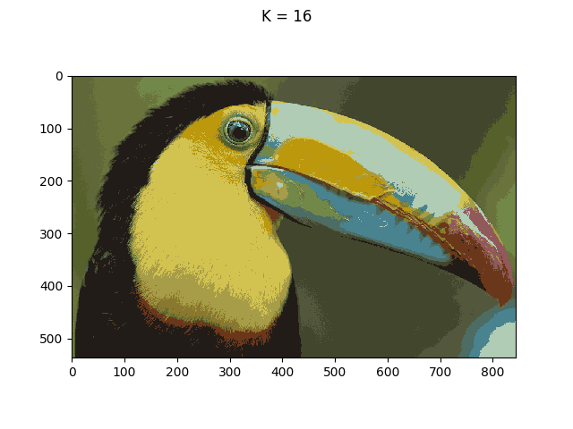

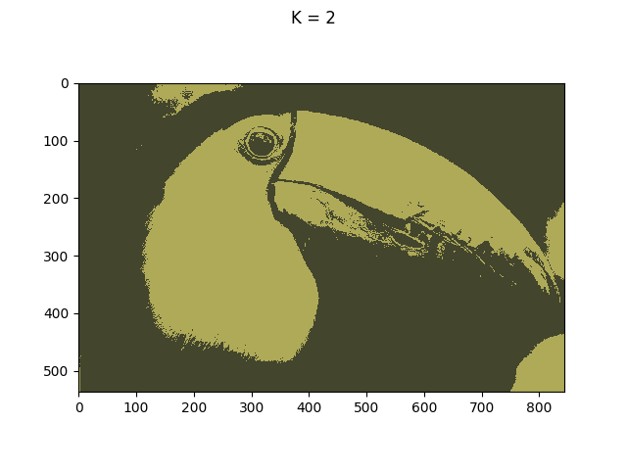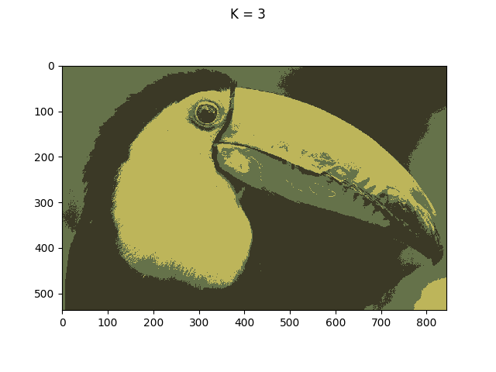

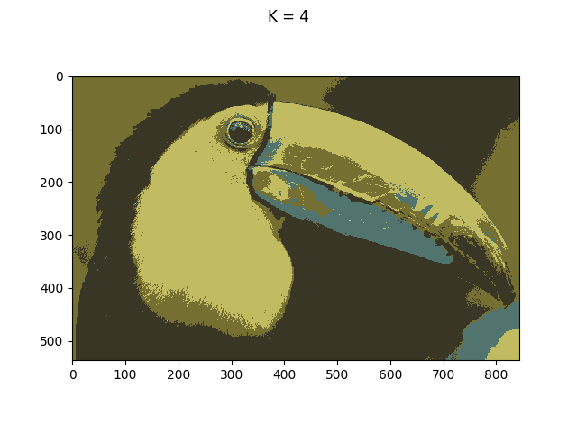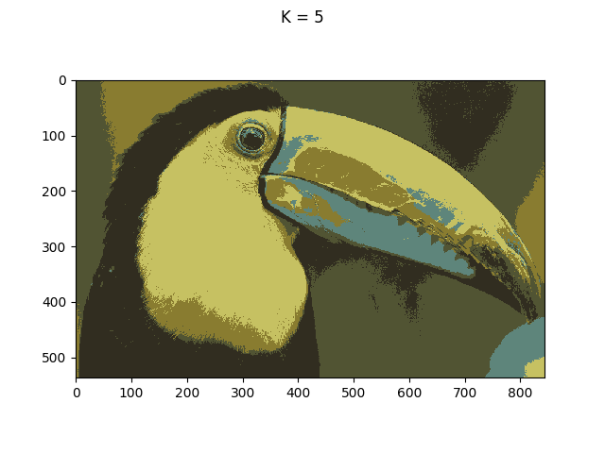

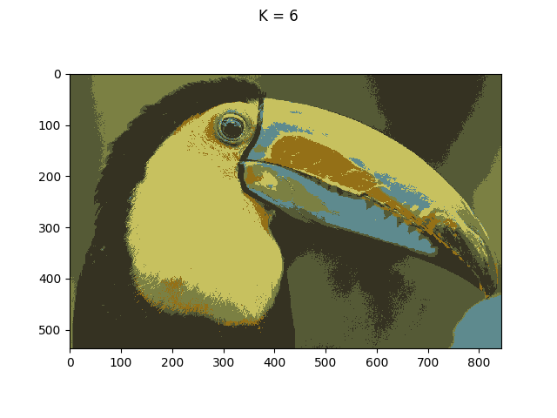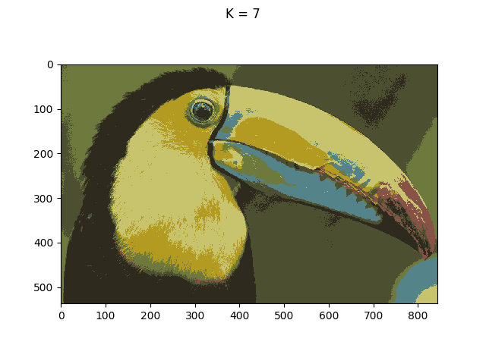

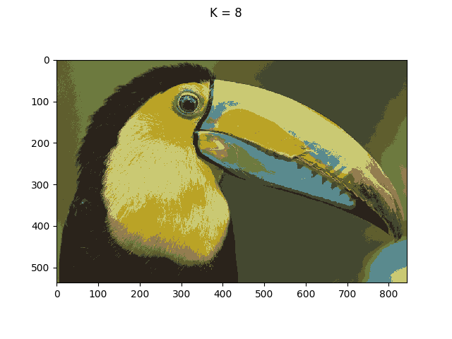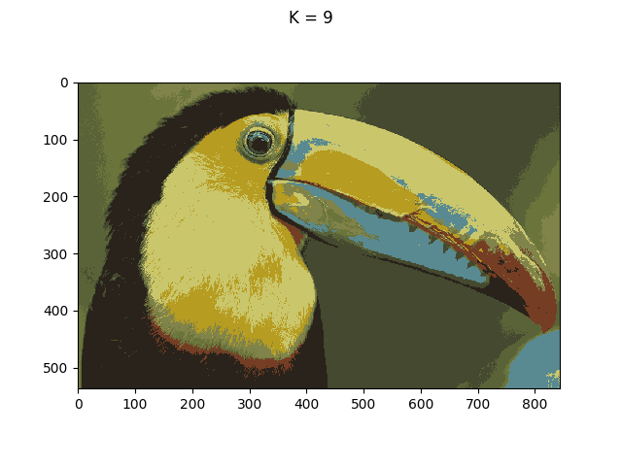

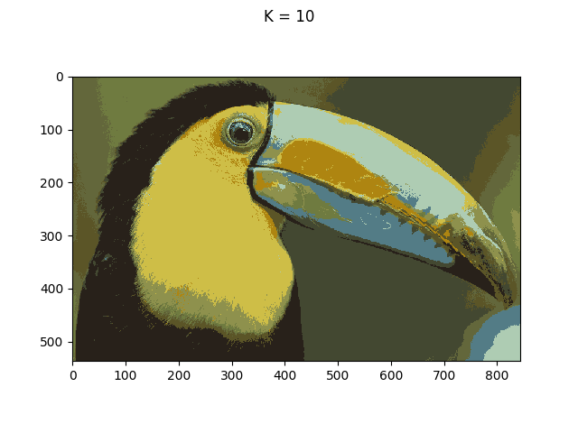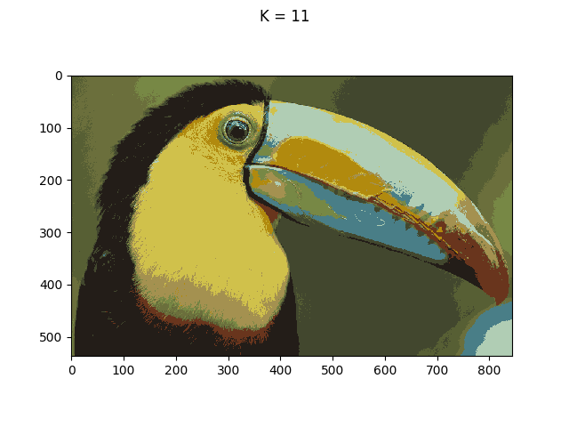

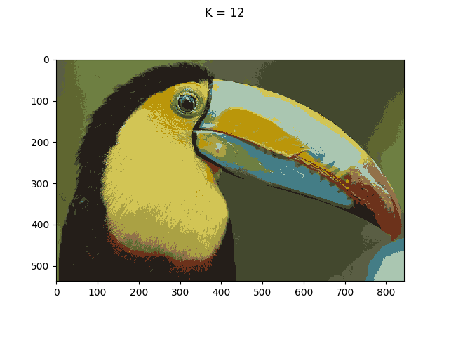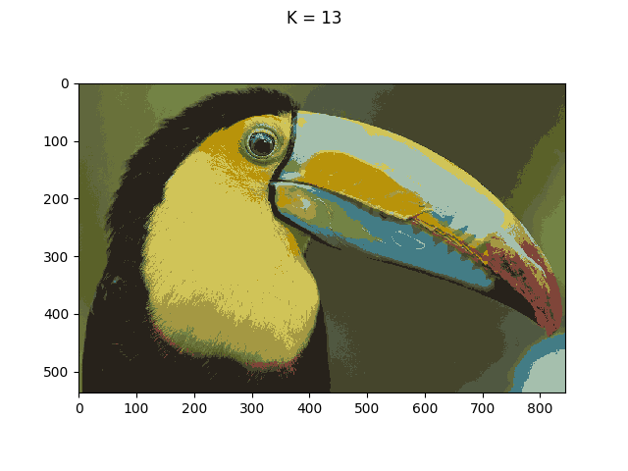

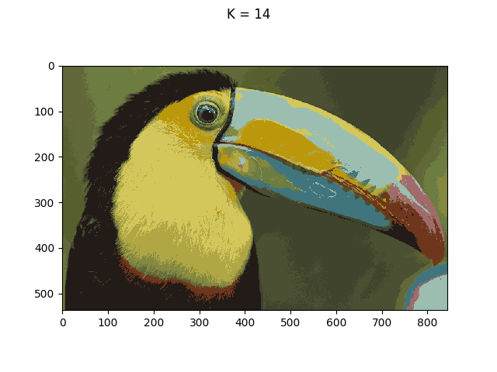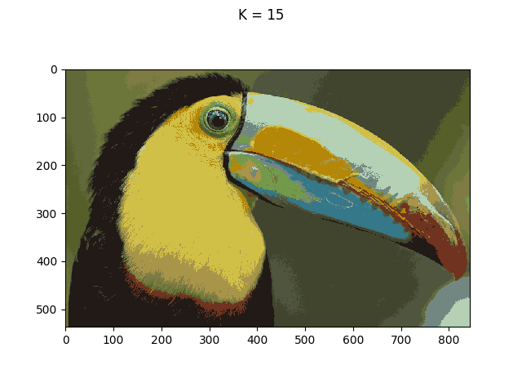

2. Select a single k between 2 and 15 and run the k-means process several times. Include the modified images from these runs. Does the algorithm find the same cluster centroids each time? Are any differences in centroid locations noticeable in the modified images?

**Solution:** The k-means algorithm found different sets of centroids for each run. The reason is that the algorithm only considers the mean RGB values and Euclid distance when finding the cluster for each pixel in image. However, the generated images look almost the same.

|  |  |  |  |
| --- | --- | --- | --- |
| **Attempt** | **K** | **Iterations** | **Centroids** |
| 1 | 5 | 25 | [[ 140. 124. 47.]  [ 196. 191. 97.]  [ 90. 132. 126.]  [ 88. 92. 53.]  [ 53. 50. 35.]] |
| 2 | 5 | 41 | [[ 199. 194. 99.]  [ 84. 88. 53.]  [ 140. 128. 49.]  [ 94. 134. 136.]  [ 51. 47. 33.]] |
| 3 | 5 | 28 | [[ 97. 139. 136.]  [ 87. 90. 52.]  [ 140. 128. 50.]  [ 200. 194. 96.]  [ 52. 48. 34.]] |
| 4 | 5 | 27 | [[ 87. 130. 126.]  [ 55. 52. 36.]  [ 197. 192. 98.]  [ 139. 128. 49.]  [ 91. 93. 52.]] |

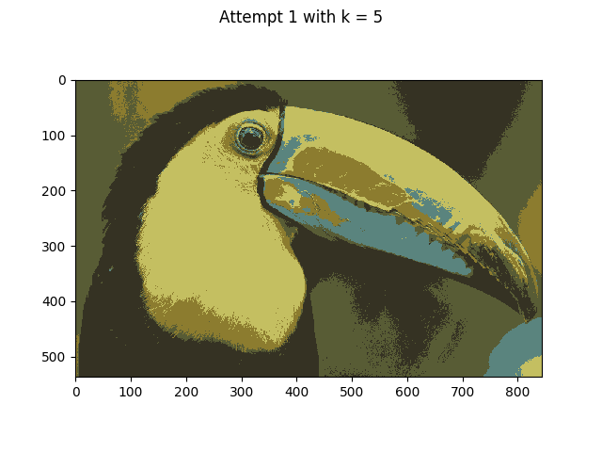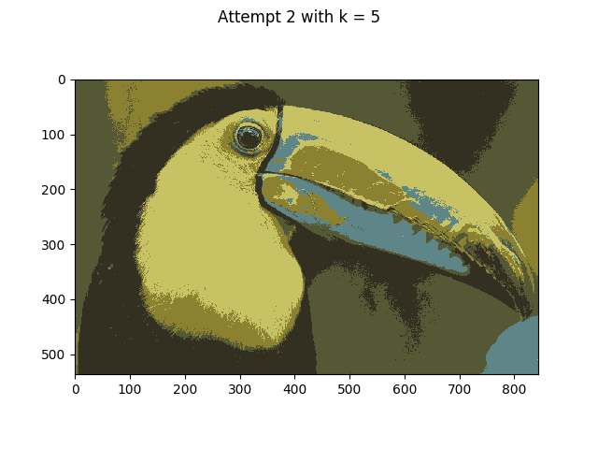

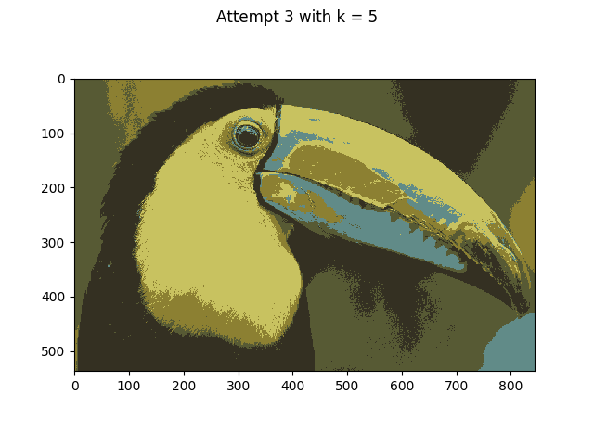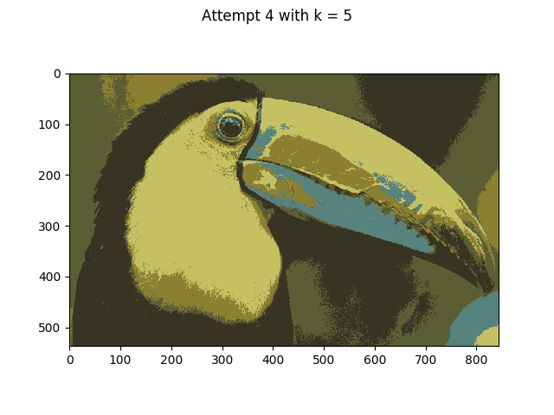

3. If you were to run the code with k = 1 how many iterations would it take to converge? What would the single centroid correspond to?

**Solution:** It will take only two iterations to converge. The single centroid is the mean of total pixels in the image.

# Code Appendix

Naïve_bayes.py

*'''*

*Created on Sep 29, 2017*

naive_bayes.py

*@author: aqd14*

*'''*

**from** **__future__** **import** division

**import** **numpy** **as** **np**

**from** **scipy** **import** misc

**from** **scipy** **import** sparse **as** sps

**import** **matplotlib.pyplot** **as** **plt**

numTokens = 2500

**class** **MultinomialNaiveBayes**():

**def** __init__(self):

self.py_pos = 0.0 *# estimates the probability that a particular word in a spam email will be the k-th word in the dictionary*

self.py_neg = 0.0 *# estimates the probability that a particular word in a non-spam email will be the k-th word in the dictionary*

self.phi_pos = 0.0 *# the probability that any particular email will be a spam email*

**def** fit(self, train_labels, train_matrix, num_tokens):

*# Training phase*

numTrainDocs = train_labels.shape[0]

spam_email_pos = np.where(train_labels==1) *# array-like: The indices of spam emails*

nonspam_email_pos = np.where(train_labels==0) *# array-like: The indices of non-spam emails*

email_word_count = np.sum(train_matrix, 1) *# array-like: The total word count for each email*

*# Calculate phi_k|y=1 = p(xj = k|y = 1)*

self.py_pos = (train_matrix[spam_email_pos].sum(axis=0) + 1) / (np.sum(email_word_count[spam_email_pos]) + num_tokens)

*# Calculate phi_k|y=0 = p(xj = k|y = 0)*

self.py_neg = (train_matrix[nonspam_email_pos].sum(axis=0) + 1) / (np.sum(email_word_count[nonspam_email_pos]) + num_tokens)

*# prior*

self.phi_pos = np.count_nonzero(train_labels)/numTrainDocs

**def** predict(self, test_labels, test_matrix):

num_test_docs = test_labels.shape[0]

log_p_pos = test_matrix.dot(np.log(self.py_pos.T)) + np.log(self.phi_pos)

log_p_neg = test_matrix.dot(np.log(self.py_neg.T)) + np.log(1 - self.phi_pos)

results = log_p_pos > log_p_neg

*# Convert from True/False to 1/0*

**return** np.squeeze(np.asarray(results.astype(dtype=int)))

**def** train_and_test(files):

*# Extract parameters*

train_labels_f = files[0]

train_features_f = files[1]

test_labels_f = files[2]

test_features_f = files[3]

*# Load the labels for the training set*

train_labels = np.loadtxt(train_labels_f,dtype=int)

*# Get the number of training examples from the number of labels*

numTrainDocs = train_labels.shape[0]

*# This is how many words we have in our dictionary*

*# Load the training set feature information*

M = np.loadtxt(train_features_f,dtype=int)

*# Create matrix of training data*

train_matrix = sps.csr_matrix((M[:,2], (M[:,0], M[:,1])), shape=(numTrainDocs, numTokens))

classifier = MultinomialNaiveBayes()

classifier.fit(train_labels, train_matrix, numTokens)

test_labels = np.loadtxt(test_labels_f, dtype=int)

*# Load the test set feature information*

N = np.loadtxt(test_features_f,dtype=int)

*# Create matrix of test data*

test_matrix = sps.csr_matrix((N[:,2], (N[:,0], N[:,1])))

prediction = classifier.predict(test_labels, test_matrix)

num_wrong_docs = np.sum(prediction != test_labels)

**print**('Number of wrong classification = {0}'.format(num_wrong_docs))

**print**('Fraction of wrong classification = {0}**\n\n**'.format(num_wrong_docs/test_labels.shape[0]))

**def** main():

files = ['pa3data/train-labels.txt', 'pa3data/train-features.txt', 'pa3data/test-labels.txt','pa3data/test-features.txt']

**print**('Working with 960-document dataset...')

train_and_test(files)

files = ['pa3data/train-labels-50.txt', 'pa3data/train-features-50.txt', 'pa3data/test-labels.txt','pa3data/test-features.txt']

**print**('Working with 50-document dataset...')

train_and_test(files)

files = ['pa3data/train-labels-100.txt', 'pa3data/train-features-100.txt', 'pa3data/test-labels.txt','pa3data/test-features.txt']

**print**('Working with 100-document dataset...')

train_and_test(files)

files = ['pa3data/train-labels-400.txt', 'pa3data/train-features-400.txt', 'pa3data/test-labels.txt','pa3data/test-features.txt']

**print**('Working with 400-document dataset...')

train_and_test(files)

**if** __name__ == '__main__':

main()

kmeans.py

*'''*

*Created on Oct 1, 2017*

*@author: aqd14*

*'''*

**import** **numpy** **as** **np**

**import** **matplotlib.pyplot** **as** **plt**

**from** **scipy** **import** misc

**def** init_centroids(A, n_clusters):

*"""*

*Initialize centroids for pixels in RGB mode (ranging from 0 to 255).*

*Randomly pick n_clusters points in the original image to be centroids.*

*Parameters*

*----------*

*n_clusters : int*

*Number of expected clusters*

*A : 3-d matrix*

*The pixels in image and their coordinates*

*Returns*

*-------*

*centroids : array-like*

*A randomly initialized centroids ranging from 0 to 255*

*"""*

centroids = A[np.random.choice(A.shape[0], n_clusters, replace=False),

np.random.choice(A.shape[1], n_clusters, replace=False), :]

**return** centroids

**def** init_cluster(centroids):

*"""Initialize cluters*

*Parameters*

*----------*

*centroids : 2-d array*

*List of centroids*

*Returns*

*-------*

*clusters : dictionary*

*Mapping from centroids to a list of points in clusters*

*"""*

clusters = {}

**for** c **in** range(centroids.shape[0]):

clusters[c] = []

**return** clusters

**def** assign_cluster(A, clusters, centroids):

*"""Assign nearest cluster for all pixels*

*Parameters*

*----------*

*A : RBG matrix representation for image*

*clusters : dictionary*

*List of centroids associated with their points in clusters*

*centroids : 2-d array*

*Current centroids*

*"""*

*# Euclid distance from given point to the centroids*

**for** i **in** range(A.shape[0]):

**for** j **in** range(A.shape[1]):

*# assign_cluster(clusters, centroids, A[i][j])*

pixel = A[i][j]

distance = np.sum((centroids - pixel) ** 2, axis=1)

*# Assign closest cluster for the given pixel*

min_index = np.argmin(distance)

clusters[min_index].append(pixel)

**def** update_centroids(clusters, centroids):

new_centroids = np.zeros((centroids.shape[0], centroids.shape[1]))

**for** c **in** range(centroids.shape[0]):

points = np.asarray(clusters[c])

**if** len(points) > 0:

new_centroids[c] = np.round(np.mean(points, axis=0))

**else**:

*# a centroid without any points*

new_centroids[c] = centroids[c]

**return** new_centroids

**def** kmeans(A, n_clusters, max_iter=100, tolerance=1e-5):

*"""Simple implementation for K-Means algorithm to compress an image by reducing the number of colors it contains*

*Parameters*

*----------*

*A : RGB matrix representation for image*

*n_clusters : int*

*Number of color clusters*

*max_iter : int*

*Maximum number of iteration for finding centroids*

*Default value is 100*

*tolerance : float*

*The minimum Euclid distance of centroids values between two consecutive iteration to be considered converged*

*Returns*

*-------*

*centroids : 2-d array*

*Converged centroids*

*"""*

centroids = init_centroids(A, n_clusters) *# default centroids*

clusters = init_cluster(centroids) *# np.zeros((A.shape[0], A.shape[1], 1)) # store the index of centroids for each pixel*

ite = 1

**while**(ite <= max_iter):

*# print('Iteration {0}'.format(ite))*

assign_cluster(A, clusters, centroids)

update_centroids(clusters, centroids)

new_centroids = update_centroids(clusters, centroids)

err = np.sqrt(np.sum((new_centroids - centroids) ** 2))

*# print('Error = {0}\n'.format(err))*

**if** err < tolerance:

**print**('Converged after {0} iterations!'.format(ite))

**break**;

centroids = new_centroids

ite += 1

**return** centroids

**def** compress_image(B, centroids):

*"""Replace each pixel in the image with its nearest cluster centroid color*

*Parameters*

*----------*

*centroids : 2-d array*

*Convergered centroids*

*B : RBG matrix image*

*Image to be compressed*

*Returns*

*-------*

*B : RBG matrix image*

*Compressed image*

*"""*

**for** i **in** range(B.shape[0]):

**for** j **in** range(B.shape[1]):

pixel = B[i][j]

distance = np.sum((centroids - pixel) ** 2, axis=1)

*# Assign closest cluster for the given pixel*

min_index = np.argmin(distance)

B[i][j] = centroids[min_index]

**def** main():

A = misc.imread('pa3data/b_small.tiff', mode='RGB')

**for** n_clusters **in** range(1, 17):

centroids = kmeans(A, n_clusters)

**print**('Centroid for clusters {0} are {1}'.format(n_clusters, centroids))

B = misc.imread('pa3data/b.tif', mode='RGB')

compress_image(B, centroids)

plt.imshow(B)

plt.suptitle('K = {0}'.format(n_clusters))

plt.savefig('figures/kmeans' + str(n_clusters) + '.png')

n_clusters = 5

**for** i **in** range(4):

centroids = kmeans(A, n_clusters)

**print**('Centroid for clusters {0} are {1}'.format(n_clusters, centroids))

B = misc.imread('pa3data/b.tif', mode='RGB')

compress_image(B, centroids)

plt.imshow(B)

plt.suptitle('Attempt {0} with k = {1}'.format(i+1, n_clusters))

plt.savefig('figures/kmeans_' + str(n_clusters) + '_' + str(i+1) + '.png')

**if** __name__ == '__main__':

main()